# **56. Wireless Architectures**

## **802.11 Message / Frame Format**



* 802.11 frames have a different format than 802.3 Ethernet frames.
* For the CCNA, you don’t need to learn it in as much detail as Ethernet and IP headers.
* Depending on the 802.11 version and message type, some fields might not be present.
  + Example: Not all messages use all four address fields.

### **Frame Components:**

* **Frame Control**
  + Provides information such as message type and subtype.
  + Indicates if the frame is a management frame.
* **Duration / ID**
  + Indicates:
    - Time (in microseconds) the channel will be dedicated to transmission.
    - Identifier for the association (connection).
* **Addresses** (Up to four may be present, depending on message type):
  + **Destination Address (DA):** Final recipient of the frame.
  + **Source Address (SA):** Original sender of the frame.
  + **Receiver Address (RA):** Immediate recipient of the frame.
  + **Transmitter Address (TA):** Immediate sender of the frame.
* **Sequence Control**
  + Used to reassemble fragments and eliminate duplicate frames.
* **QoS Control**
  + Prioritizes certain traffic.
* **HT (High Throughput) Control**
  + Added in 802.11n to enable high throughput operations.
  + 802.11n = "High Throughput" (HT) Wi-Fi.
  + 802.11ac = "Very High Throughput" (VHT) Wi-Fi.
* **FCS (Frame Check Sequence)**
  + Same as in an Ethernet frame, used to check for errors.

## **802.11 Association Process**

* Access Points (APs) bridge traffic between wireless stations and other devices.
* A station must be associated with an AP to send traffic.
* **Three 802.11 connection states:**
  1. Not authenticated, not associated.
  2. Authenticated, not associated.
  3. Authenticated and associated.

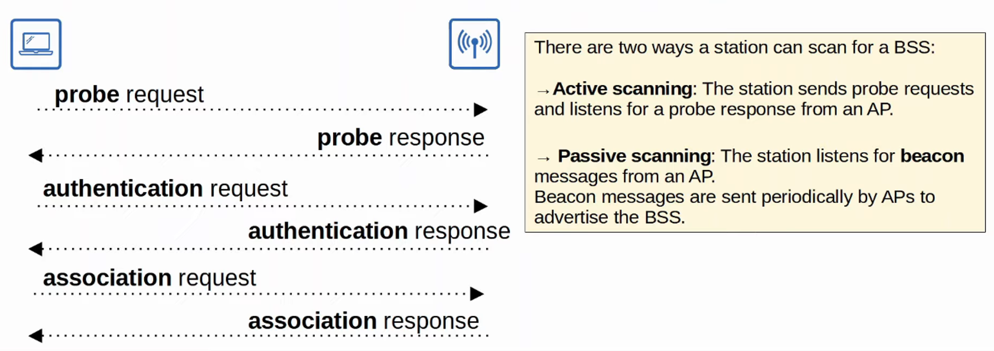

## **802.11 Message Types**

There are three types of 802.11 messages:

1. **Management** (Used to manage the BSS):
   * Beacon
   * Probe Request / Probe Response
   * Authentication
   * Association Request / Association Response
2. **Control** (Used to control access to the medium and assist with frame delivery):
   * RTS (Request to Send)
   * CTS (Clear to Send)
   * ACK
3. **Data** (Used to send actual data packets)

## **Autonomous APs**

* Autonomous APs are self-contained systems that do **not** rely on a Wireless LAN Controller (WLC).
* They are configured individually via:
  + Console cable (CLI)
  + Telnet (CLI)
  + HTTP/HTTPS Web connection (GUI)
* Configuration requirements:
  + IP address for remote management.
  + Manual configuration of RF parameters (Transmit Power, Channel, etc.).
  + Security policies and QoS rules handled individually by each AP.
  + No central monitoring or management.

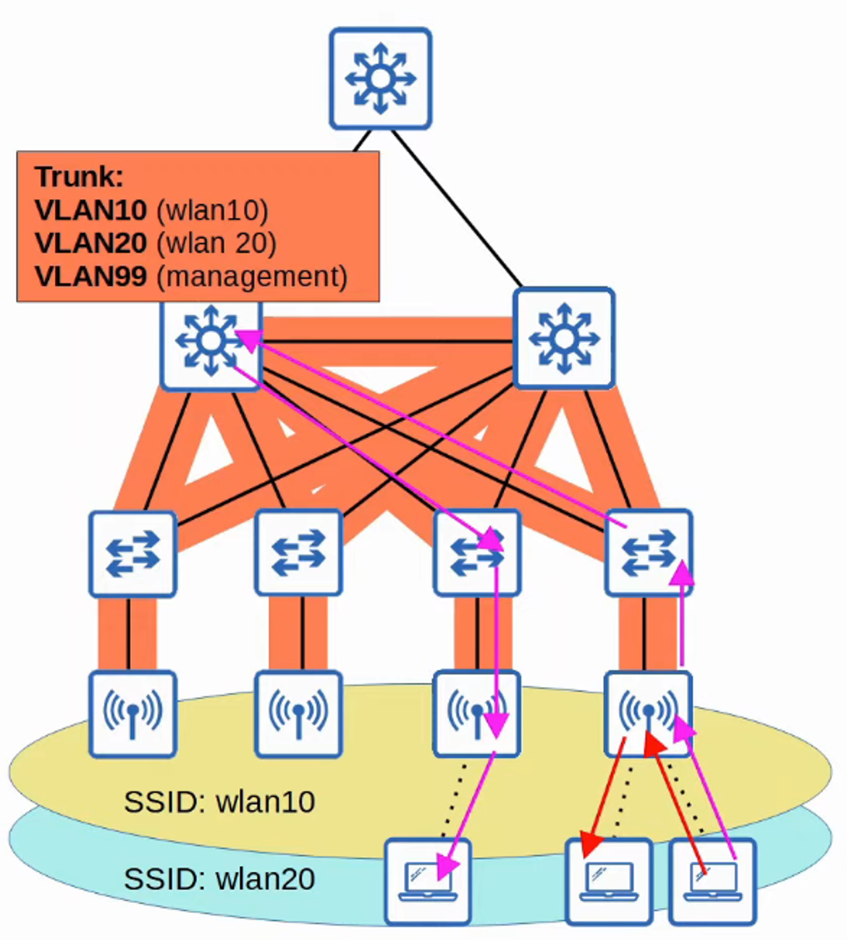

* Connects to the wired network via a trunk link.
* Each VLAN must stretch across the entire network, which is considered bad practice due to:
  + Large broadcast domains.
  + Spanning Tree disabling links.
  + Labor-intensive VLAN management.
* Suitable for **small networks**, but not viable for **medium or large networks**.
* Autonomous APs can also operate in:
  + **Repeater Mode**
  + **Outdoor Bridge Mode**
  + **Workgroup Bridge Mode**

## **Lightweight APs**

* Functions are split between the AP and a **Wireless LAN Controller (WLC)** (Split-MAC Architecture).
* **Lightweight AP Functions:**
  + Transmitting/receiving RF traffic.
  + Encryption/decryption.
  + Sending out beacons/probes.
  + Packet prioritization.
* **WLC Functions:**
  + RF management.
  + Security/QoS management.
  + Client authentication and association/roaming management.
  + Centralized resource allocation.
* **WLC & AP Authentication:**
  + They authenticate each other using X.509 digital certificates.
  + Ensures only authorized APs join the network.

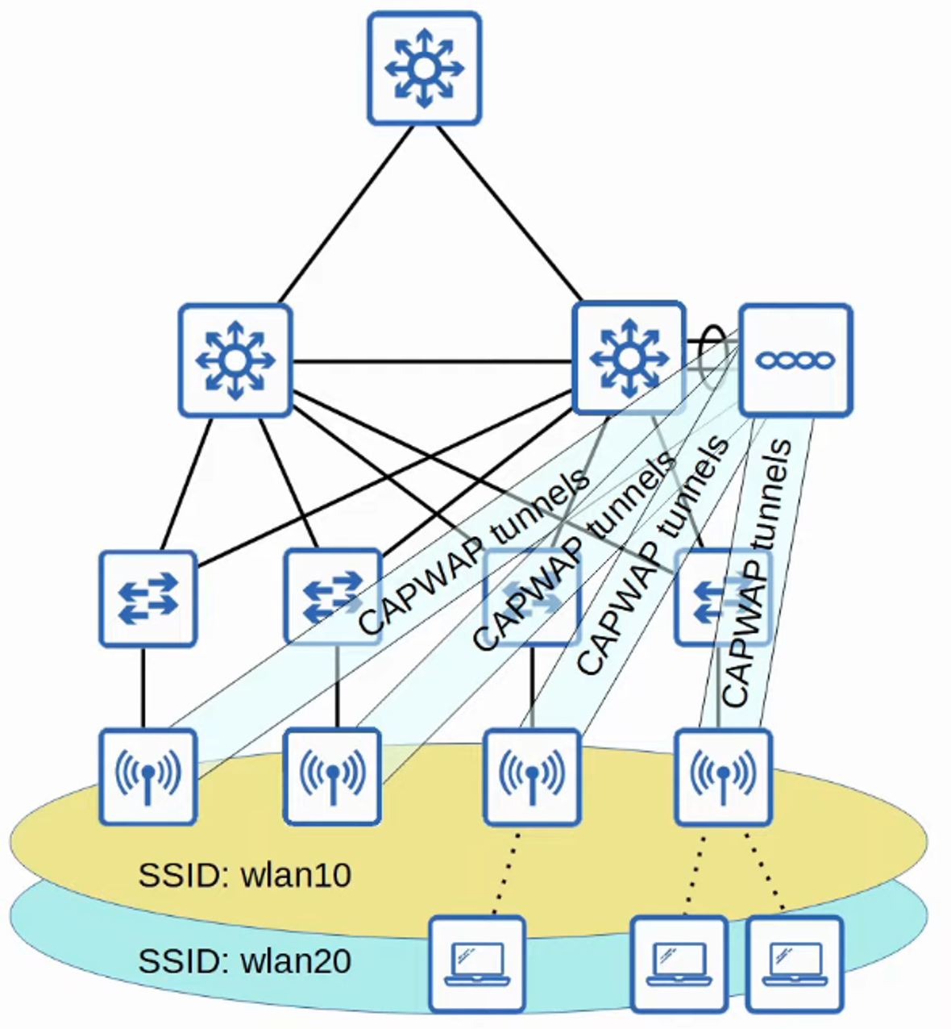

* **CAPWAP Protocol (Control and Provisioning of Wireless Access Points):**
  + Used for AP-WLC communication.
  + Two tunnels:
    1. **Control Tunnel (UDP Port 5246):** Used for configuration and management (encrypted by default).
    2. **Data Tunnel (UDP Port 5247):** Wireless client traffic (not encrypted by default, but can be encrypted with DTLS).
* **Access ports are used for Lightweight APs, not trunk ports.**

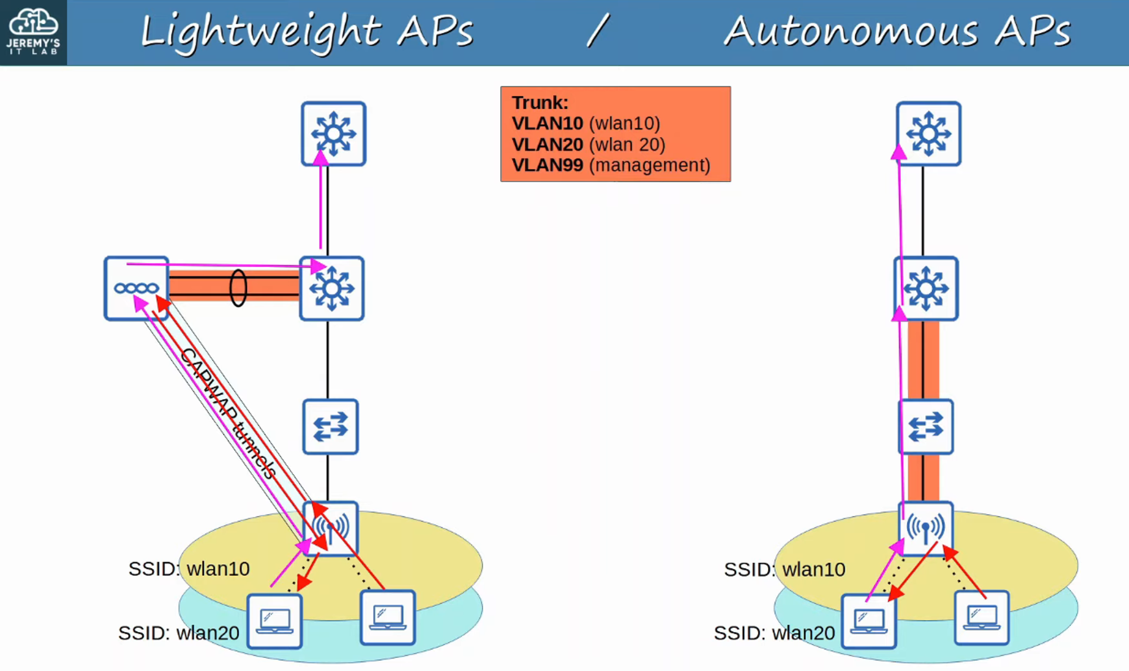

## **Benefits of Split-MAC Architecture (Not necessary to memorize for CCNA):**

* **Scalability:** Easier to support thousands of APs.
* **Dynamic Channel Assignment:** WLC selects optimal channels automatically.
* **Transmit Power Optimization:** WLC adjusts power settings dynamically.
* **Self-Healing Wireless Coverage:** WLC increases power of nearby APs if one fails.
* **Seamless Roaming:** Clients can roam between APs without noticeable delay.
* **Client Load Balancing:** WLC distributes clients efficiently.
* **Security & QoS Management:** Ensures network-wide consistency.

## **Lightweight AP Operating Modes**

* **Local Mode (Default):** AP offers one or more BSSs for clients to associate with.
* **FlexConnect Mode:**
  + Allows local switching between wired and wireless networks if WLC tunnels go down.
  + AP connects via a **trunk link** instead of an access port.

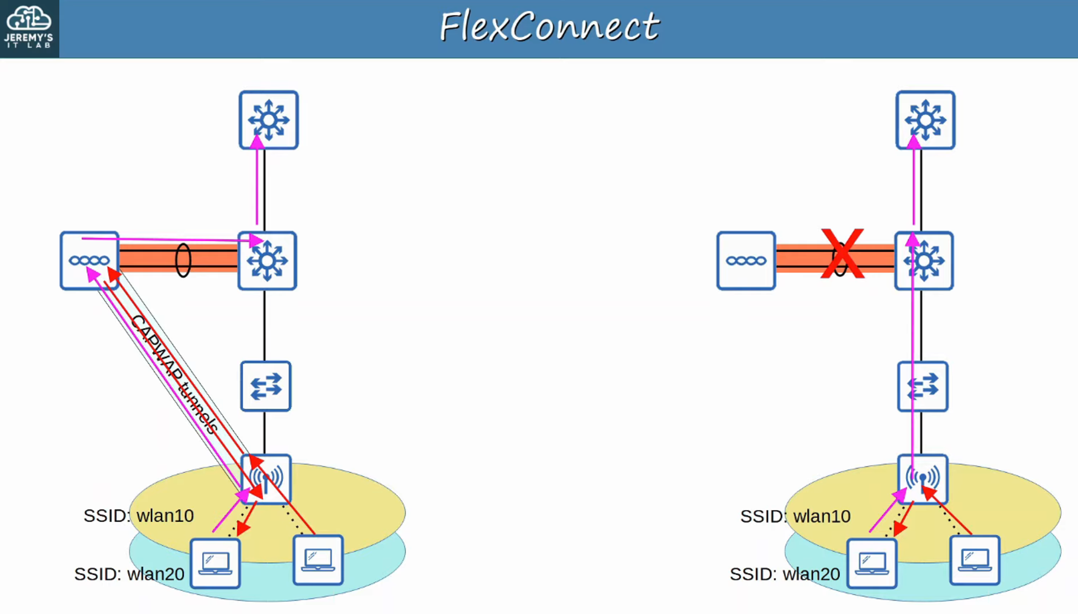

### **Specialized Modes:**

* **Sniffer Mode:** Captures 802.11 frames and sends them to Wireshark.
* **Monitor Mode:** Detects rogue devices; can send de-authentication messages.
* **Rogue Detector Mode:** Listens for ARP messages on the wired network to identify rogue clients/APs.
* **SE-Connect (Spectrum Expert Connect):** Performs RF spectrum analysis.
* **Bridge/Mesh Mode:** Used for long-distance point-to-point or point-to-multipoint links.
* **Flex Plus Bridge:** Adds FlexConnect capabilities to bridge/mesh mode.

**# CLOUD-BASED APs**

* Cloud-based AP architecture falls between **Autonomous AP** and **Split-MAC Architecture**.
  + **Autonomous APs** that are centrally managed in the cloud.
* **Cisco Meraki** is a popular cloud-based Wi-Fi solution.
* The **Meraki Dashboard** allows users to:
  + Configure APs.
  + Monitor the network.
  + Generate performance reports.
  + Manage AP channel selection, transmit power, etc.
* However, **data traffic is not sent to the cloud**; it is sent directly to the wired network like autonomous APs.
  + Only **management and control traffic** is sent to the cloud.

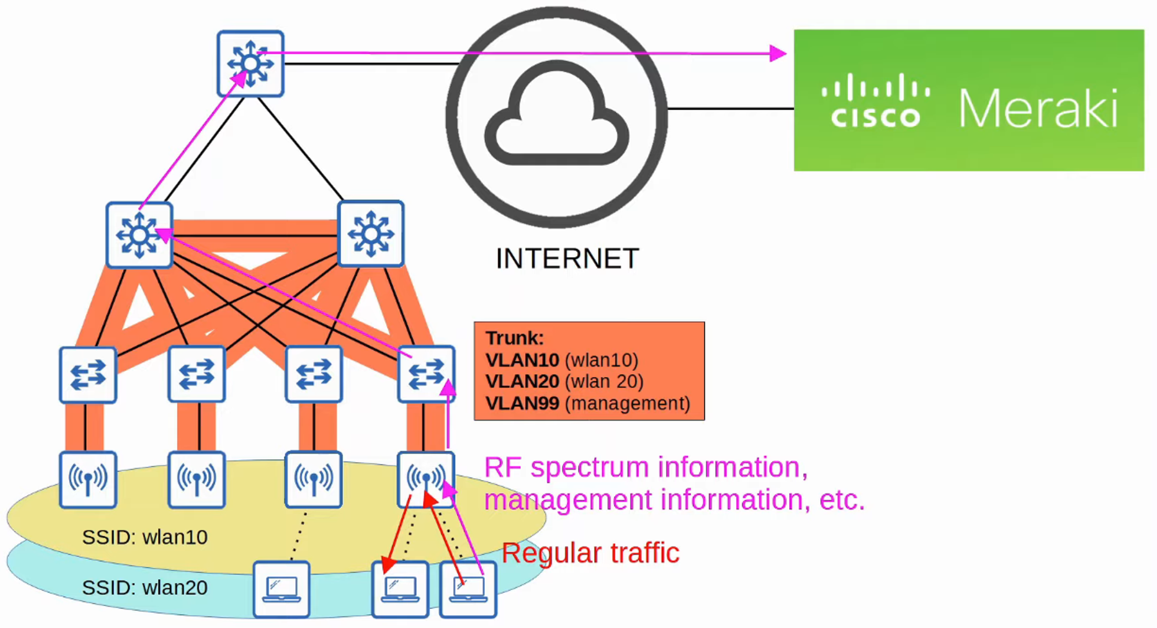

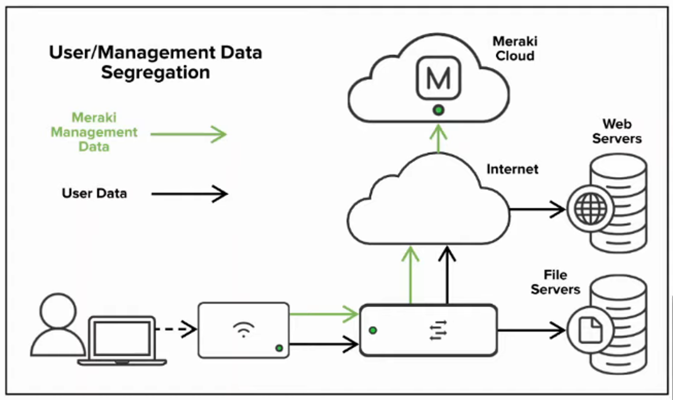

**# WIRELESS LAN CONTROLLER (WLC) DEPLOYMENTS**

In a **Split-MAC Architecture**, there are **four main WLC deployment modes**:

1. **Unified WLC -> Support greatest number of APs**
   * The WLC is a **hardware appliance** in a central location of the network.
2. **Cloud-Based WLC**
   * The WLC is a **virtual machine (VM) running on a server**, typically in a private cloud or data center.
   * **Note:** This is **not** the same as cloud-based AP architecture.
3. **Embedded WLC**
   * The WLC is **integrated within a switch**.
4. **Mobility Express WLC**
   * The WLC is **embedded within an AP**.

**# UNIFIED WLC**

* The WLC is a **hardware appliance** in a central location of the network.
* A **unified WLC** can support up to **6,000 APs**.
* If more than **6,000 APs** are required, additional WLCs can be added to the network.

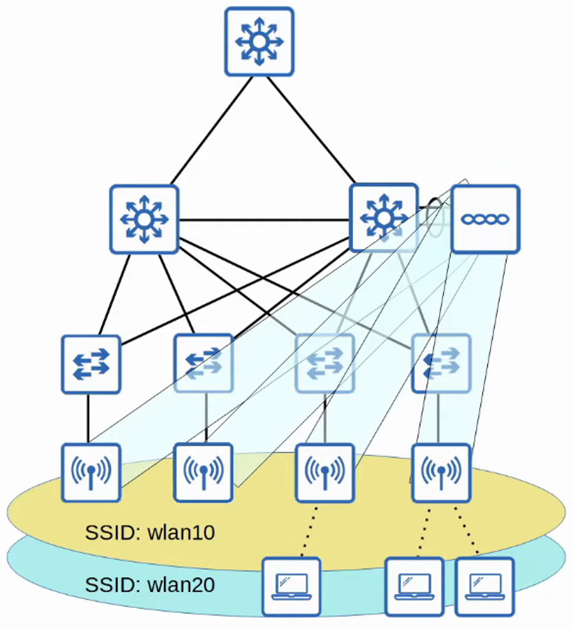

**# CLOUD-BASED WLC**

* The WLC is a **VM running on a server**, typically in a **private cloud or data center**.
* **Cloud-based WLCs** can support up to **3,000 APs**.
* If more than **3,000 APs** are needed, additional **WLC VMs** can be deployed.

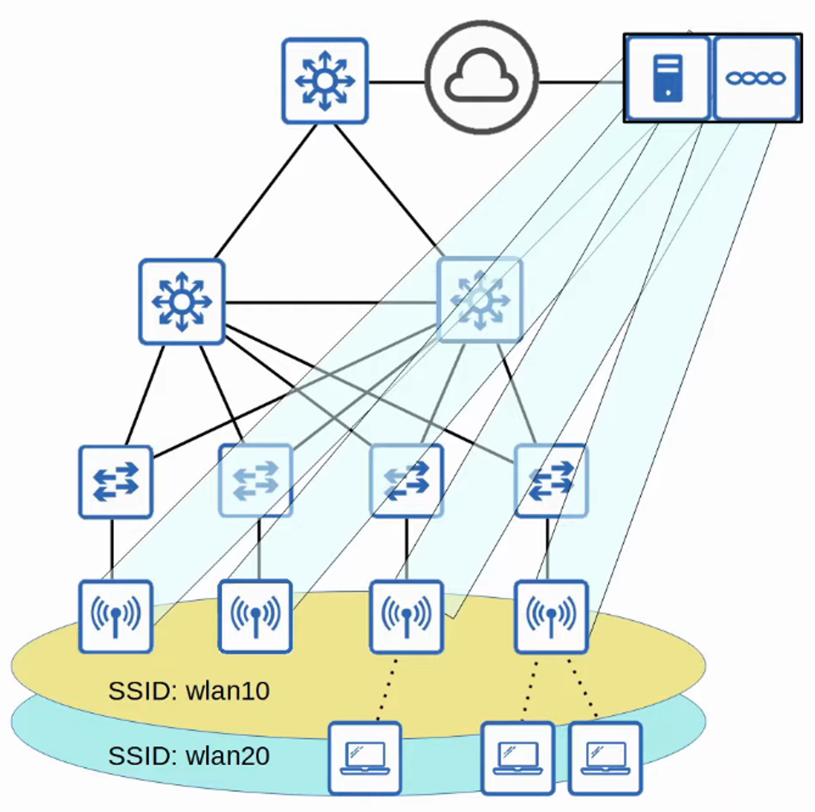

**# EMBEDDED WLC**

* The WLC is **embedded within a switch**.
* An **embedded WLC** can support up to **200 APs**.
* If more than **200 APs** are required, additional switches with **embedded WLCs** can be added.

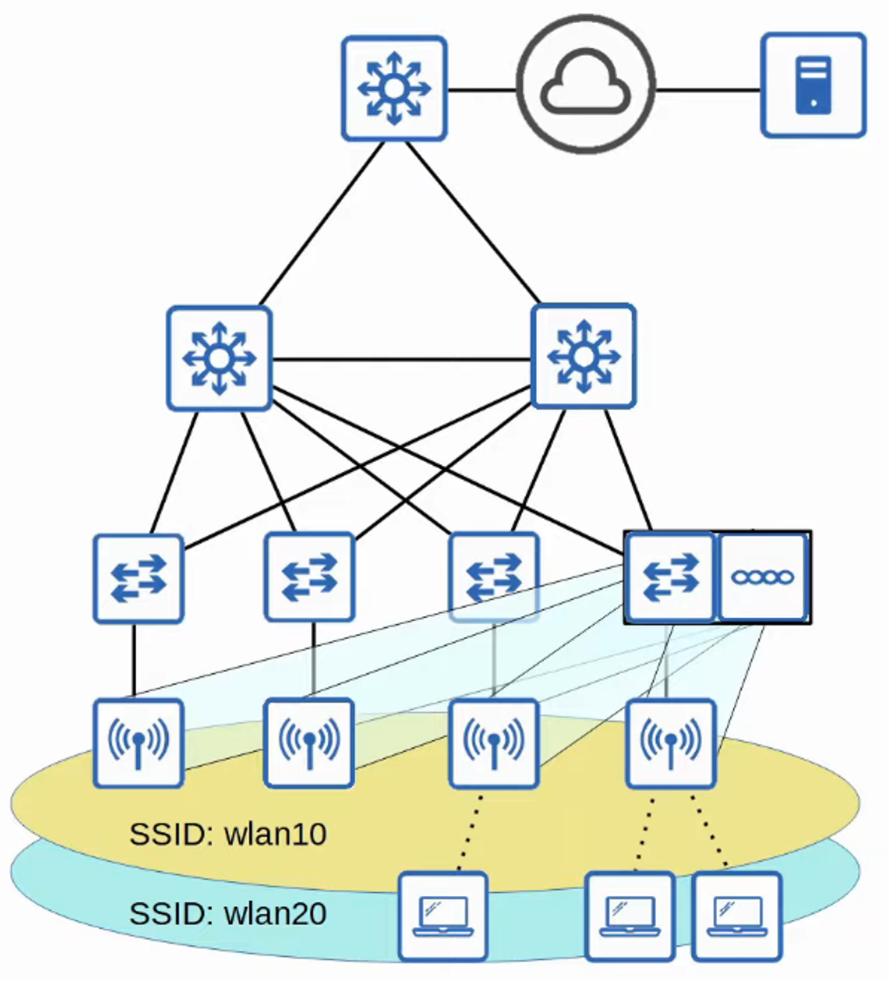

**# CISCO MOBILITY EXPRESS WLC**

* The WLC is **embedded within an AP**.
* A **Mobility Express WLC** can support up to **100 APs**.
* If more than **100 APs** are required, additional APs with **embedded Mobility Express WLCs** can be deployed.

